Salesforce Playbook

What is Salesforce? 🤔

Salesforce is your go-to CRM (Customer Relationship Management) tool that helps you track, manage, and document merchant interactions efficiently.

As a Business Consultant, you’ll use Salesforce to:
✅ Document merchant information – Keep track of key details and interactions.
✅ Manage the sales pipeline – Move deals through different stages as they progress.
✅ Ensure smooth follow-ups – Never lose track of a potential deal.

Think of Salesforce as your digital command center, keeping everything organized so you can focus on closing deals and onboarding merchants effectively! 🚀

Post-Mock Test: Documenting Your Sales Process 📌

Now that you've completed your Mock Test, it's time to put your Salesforce skills into action!

✅ Create a Salesforce Lead – Click on this form and fill in the required details. You'll need to create a separate lead for both your F&B and Retail mock merchants to ensure accurate documentation.

Lead Details
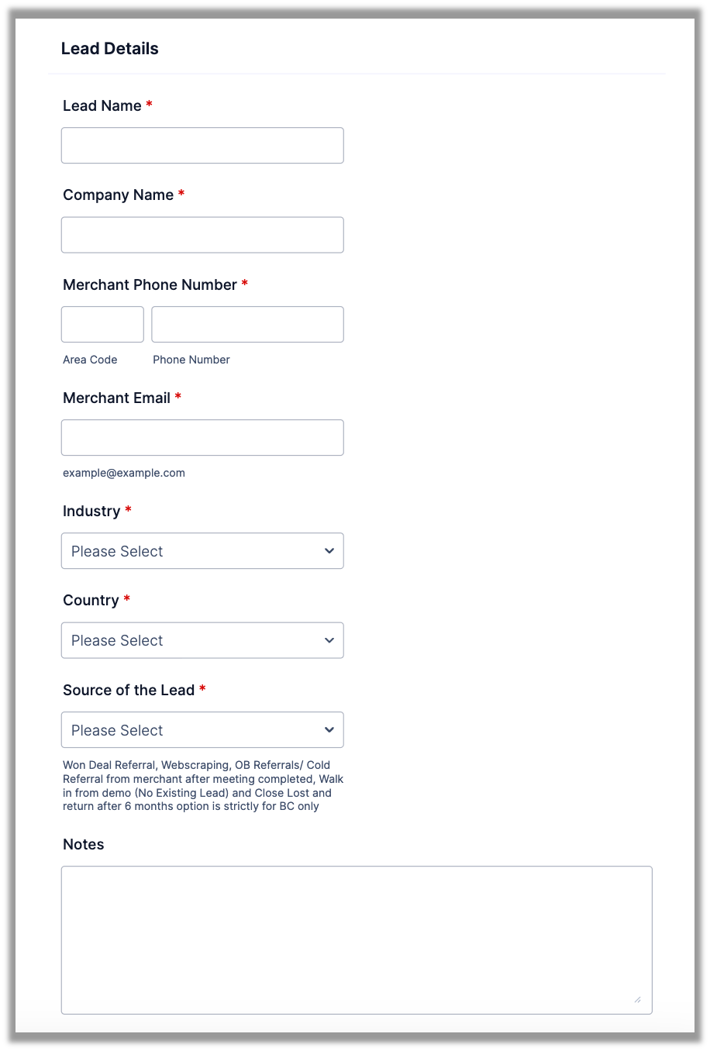

- Lead Name: Enter the merchant’s name exactly as provided in your Mock Test.
Example: If the merchant is Noodles Valley, enter it as → [Mock F&B] Noodles Valley

- Company Name: Key in your name
Example: [Mock Test] Andrea

- Merchant Phone Number: Key in any number. Ensure both leads are not using the same number otherwise it will detect duplicate accounts.
Example: F&B Lead: 0102223456 | Retail Lead: 0112234556

- Merchant Email: Key in an email, use different emails for both Leads.

- Industry: Select the leads designated Industry.
Example: When you are filling up the form for a F&B account, select F&B.

- Country: Select MY

- Source of the Lead: Select Testing (Outbound Lead)
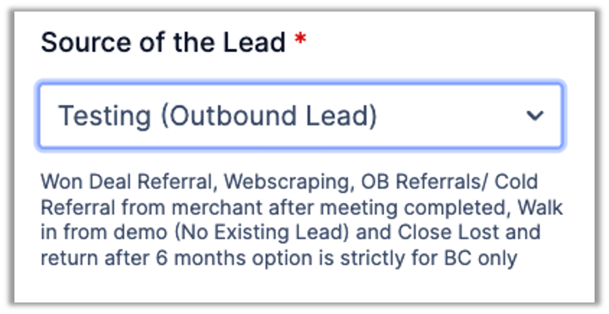

- Notes: Leave a note; saying its for mock test purposes.

Submitter Details
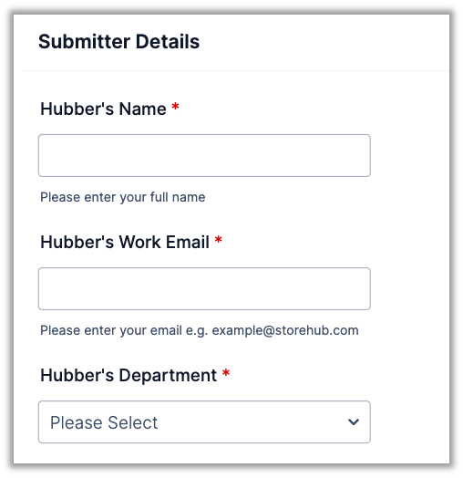
- Hubber Name: Key in your name

- Hubber's Work Email: Key in your StoreHub email

- Hubber's Department: Select Business Consultant

Once you fill out the form, check your Salesforce account and look for the leads.

✅ Move the Lead to Opportunity Stage – Document the merchant's details from your Mock Test and accurately reflect their progress in the sales pipeline.

A Salesforce Playbook has been prepared for you, providing a detailed step-by-step guide to follow. Make sure to use it to ensure accuracy and consistency!

This step is crucial in simulating real-world sales documentation, so take your time and get it right.

